DAC619 AI for Games

# Monte Carlo Tree Search Lab

1. 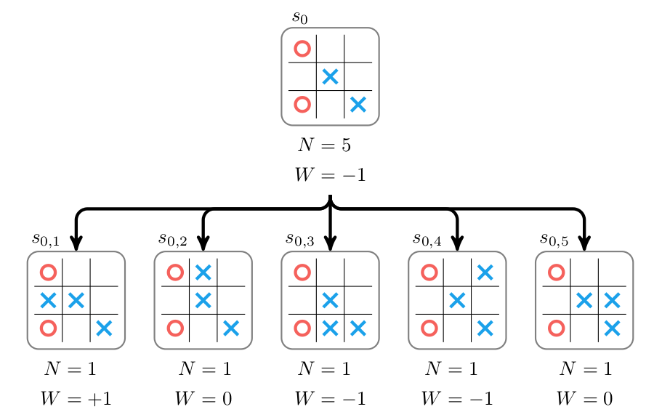You are given a partial game tree for Tic-Tac-Toe and $N$ and $W$ values for a number of previous iterations are provided in that tree. The game state is close to a win for $×$, Using the formula for UCT, below, $$U_{i}=\frac{W_{i}}{N_{i}}+c\sqrt{\frac{\ln{N_{P}}}{N_{i}}}$$ 
     
   and given a value of $c=1$, calculate the value $U_{i}$ for all nodes for this iteration, select the node with the highest $U_{i}$ value and then expand, play through with random moves and then backpropagate when a leaf node (win or lose state) is reached by updating the $W_{i}$, $N_{i}$ and $N_{P}$ values appropriately.  
   If you have time, repeat this for another iteration.
2. Read the provided white paper describing Google’s AlphaGo algorithm.